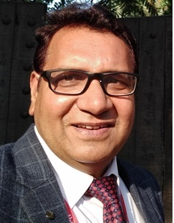

Dr. Shyam S. Sharma is Professor and Head, Department of Pharmacology and Toxicology, National Institute of Pharmaceutical Education and Research (NIPER), Mohali and Vice President of Indian Pharmacological Society. Before joining NIPER in 1999 as Assistant Professor, he worked as postdoctoral fellow at the University of Illinois at Chicago, USA. He did his PhD (Pharmacology) from AIIMS, New Delhi and M. Pharm. and B. Pharm. from DIPSAR, New Delhi. Dr Sharma is a Fellow of Indian Pharmacological Society (FIPS) and has more then 30 years of experience in preclinical and mechanistic studies for NCEs of various therapeutic areas (Stroke, Parkinson’s and Alzheimer’s disease and diabetic complications) as well as in safety pharmacology. He has published about 200 peer reviewed research papers/patents/book chapters with > 9000 citations with h-index 51 and i10 index 152. He has guided >150 master’s & doctorate students. He has completed more than 20 extramural and industry funded projects. He is recipient of OPPI Scientist Award, Shakuntala Amir Chand Prize and Dr D N Prasad Memorial Oration Award of Indian Council of Medical Research, PP Suryakumari Prize and Dr NS Dhalla award of Indian Pharmacological Society (IPS). Recently, Dr Sharma received PharmInnova Best Research Guide Award 2026.

